Chapter 17, Solution 20.

Find the Fourier series for the signal in Fig. 17.58. Evaluate f(t) at t = 2 using the first three nonzero harmonics.

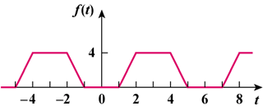

Figure 17.58
For Prob. 17.20.

Solution

This is an even function.

b_{n} = 0, T = 6, ω = 2π/6 = π/3

a_{o} =

= = 2

a_{n} =
= (4/6)[ + ]

=

= [24/(n²π²)][cos(2nπ/3) − cos(nπ/3)]

Thus f(t) =

At t = 2,

f(2) = 2 + (24/π²)[(cos(2π/3) − cos(π/3))cos(2π/3)

+ (1/4)(cos(4π/3) − cos(2π/3))cos(4π/3)

+ (1/9)(cos(2π) − cos(π))cos(2π) + -----]

= 2 + 2.432(0.5 + 0 + 0.2222 + -----)

f(2) = 3.756

